**Sample 2**

**The graph shows** the number of immigrants to New Zealand from various parts of the world for the month of August in the years 2007 to 2009. **Different trends can be seen for**people arriving from North America, Asia and Europe, while immigrants from Mainland China showed the greatest increase as well as made up the largest proportion of immigrants throughout most of this time period.

**The figures for people moving to New Zealand from different regions of the world showed diverse tendencies.** The numbers of North American immigrants firstly peaked at a little over 150 for Canada and just under 400 for the USA in August 2008, then declined by around 60 to 80 the following year. Long-term arrivals in New Zealand from two European countries showed a continuous slight rise, with numbers of French and Germans reaching around 70 and 310 in 2009 respectively.

**In contrast, the figures for permanent arrivals from** two Asian regions, Hong Kong and Mainland China, **showed completely different trends.**The number of Mainland Chinese immigrants grew sharply, almost doubling from about 300 in August 2007 to approximately 550 in 2009, comprising the largest group by 2009, around twice the size of the groups from America and Germany. On the other hand, numbers of Hong Kongers settling in New Zealand remained stable at roughly 50 per year, only around one-tenth the numbers of Mainland Chinese in 2009.

**To sum up, areas in three different continents displayed different trends.** The numbers for mainland Chinese immigrants rose most dramatically and in 2009 represented the largest group, while Hong Kongers comprised the smallest numbers.

**Sample 3**

**The bar chart shows the cost of buying different photocopiers, the cost of a warranty on each machine, and their expected running costs for the first two years. Using the information from the chart, write a short report comparing the costs for the three machines.  
Write 120-140 words.**

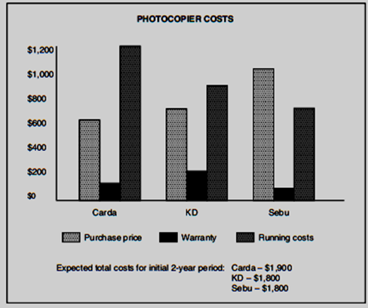

**Photocopier Costs**

**The bar chart shows the cost of buying different photocopiers, the cost of a warranty on each machine, and their expected running costs for the first two years.**

**Of the three types of photocopiers, Carda, KD and Sebu, the purchase price of the Carda is the lowest.**It is slightly more than $600 but its expected running cost for the first two years is the highest with its warranty cost at the mid-level of the three photocopiers.

**In comparison,**the purchase price of the KD is a little more than that of the Carda which is $700; whereas the expected running cost of the KD is much less than that of the Carda which is $1,200. However, the KD’s warranty cost is the highest of the three at $200.

In comparison the Sebu’s purchase price is the highest of the three, i.e. $1000, but it costs consumers the least in warranty and running for the first two years. What’s more, the expected total cost of the Carda for the initial 2-year period is $1,900, more than that of both the Sebu and KD, $1,800.

**In conclusion, it would be advisable to buy the KD photocopier which is generally more advantageous in cost than its competitors.**

**Sample 4**

**The graph below shows the turnover for three kinds of retail outlet, all owned by the same company, during a three-year period. Using the information from the graph, write a short report comparing the changes in turnover in the company’s three types of outlet (120-140 words).**

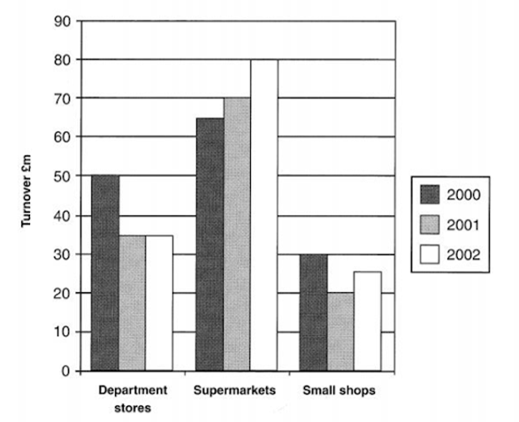

**This report details the main changes in turnover based on category of retail sector from 2000 to 2002, a period of three years.**

Supermarkets increased their turnover steadily throughout the three year period and reached £80m in 2002. Department stores reported turnover of £50m in 2000, however, this fell to £35m the following year, and then remained steady in 2002. In 2001 the small shops-outlets sector experienced a loss in terms of turnover, dropping by £10m from the £30m achieved in 2000, however, in 2002 this sector recovered somewhat with turnover of £25m.

**Throughout the period, without exception, turnover produced by the supermarket sector was the highest among the three different categories.** The turnover produced by department stores was the second highest, and the small shop-outlets sector was the source of least turnover.

**Sample 5**

**Write a report for a university lecturer describing the information in the graphs below. Write at least 150 words.**

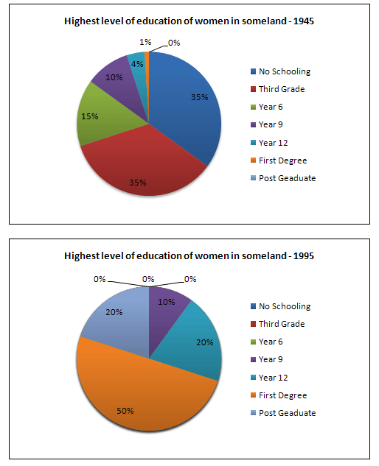

**The pie charts compare the highest level of education achieved by women in Someland across two years, 1945 and 1995. It can be clearly seen that women received a much higher level of education in Someland in 1995 than they did in 1945.**

In 1945 only 30% of women completed their secondary education and 1% went on to a first degree. No women had completed post-graduate studies. **This situation had changed radically by 1995.**In 1995, 90% of women in Someland had completed secondary education and of those, half had graduated from an initial degree and 20% had gone on to postgraduate studies.

At the other end of the scale, we can see that by 1995 all girls were completing lower secondary, although 10% ended their schooling at this point. **This is in stark contrast with** 1945 when only 30% of girls completed primary school, 35% had no schooling at all and 35% only completed the third grade.

**In conclusion, we can see that in the 50 years from 1945 to 1995 there have been huge positive developments to the education levels of women in Someland.**